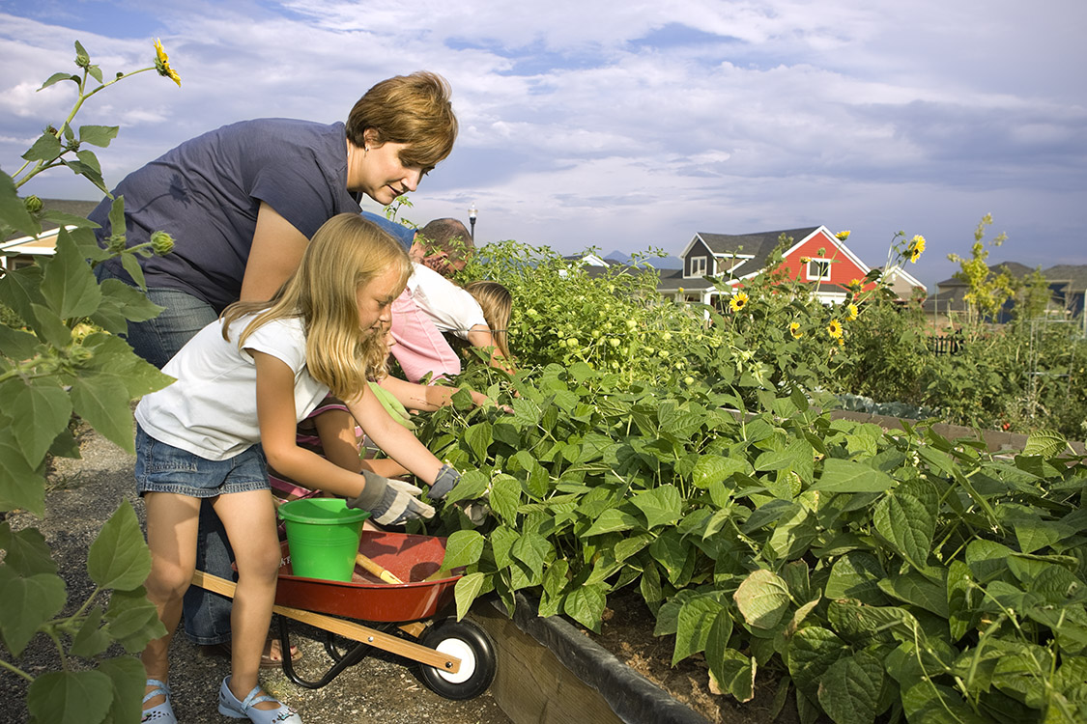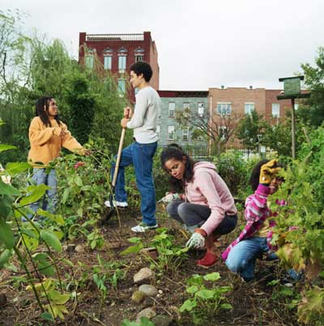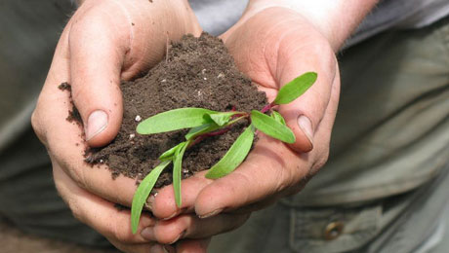

**The garden group will start meeting in March 2014 and work once week in the garden from April to October 2014.**

**A plot of land, gardening supplies and equipment will be provided**

**We want to hear from you…**

**Please Fill Out Our Survey**

**Taking part in the garden will be a great chance to**

* connect with others
* work with the earth, sun and nature
* learn new skills
* share the harvest of healthy foods

**A gardener will help the group learn how to**

* plan rows
* decide types of foods to grow
* prepare the soil
* plant the seeds
* weed the garden
* harvest

**The Orangeville Food Bank would like to work with a small group of people interested in growing a community garden**.

**Let’s Grow A Garden in 2014**

**Let’s Grow a Garden in 2014 - Survey**

The Orangeville Food Bank would like to hear from you about starting a community garden.

Please fill out this short survey.

1. Would you like to take part in a community garden?

Yes _____ No ______

2. If yes, why would you like to take part in a community garden? If no, please explain.

_____________________________________________________________________________________________________________________________________________________________________________________________________________________________________________________________________

3. What do you think would help to make a community garden a success and why?

_____________________________________________________________________________________________________________________________________________________________________________________________________________________________________________________________________

If you are interested in taking part in the Orangeville Food Bank Community Garden please fill in your Contact Information below and we will call you.

Name ______________________________

Phone #____________________________

Thank You - The Orangeville Food Bank